vkj-,l-ds- esa egRoiw.kZ e”khusa
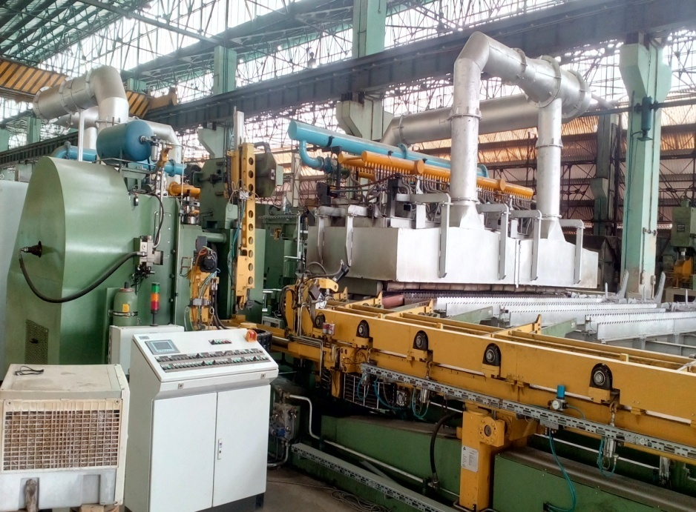 | 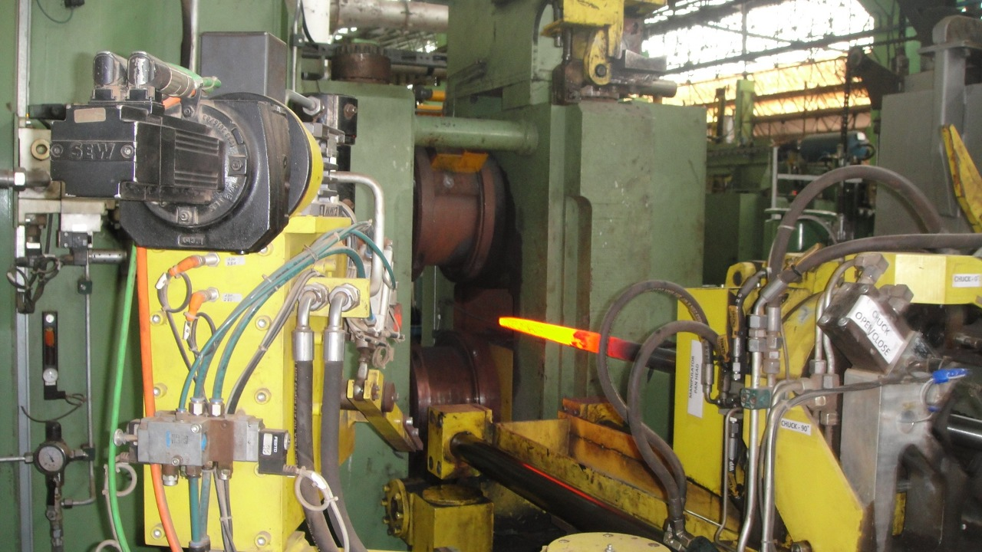
,.M Vsifjax e”khu
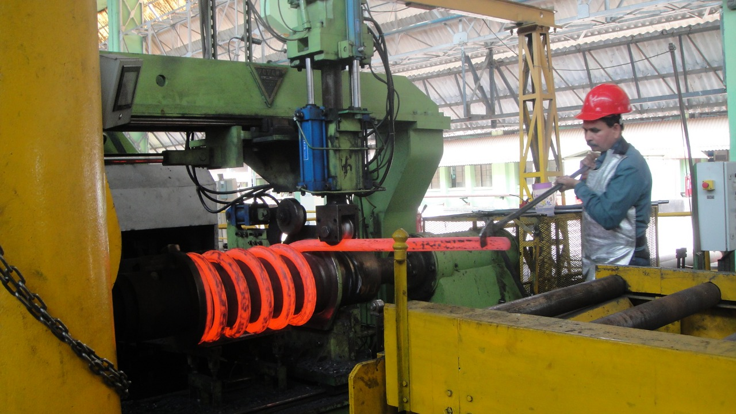 | 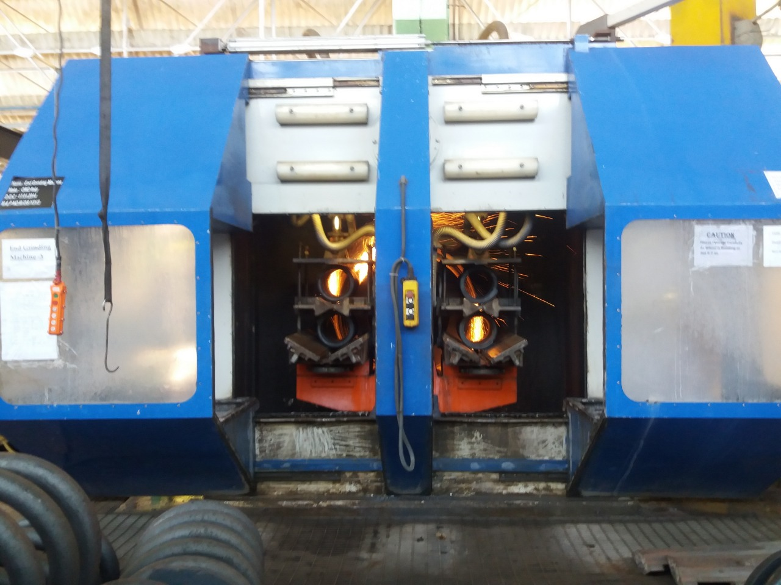
DokWbfyax e”khu | ,.M xzkbfMax e”khu
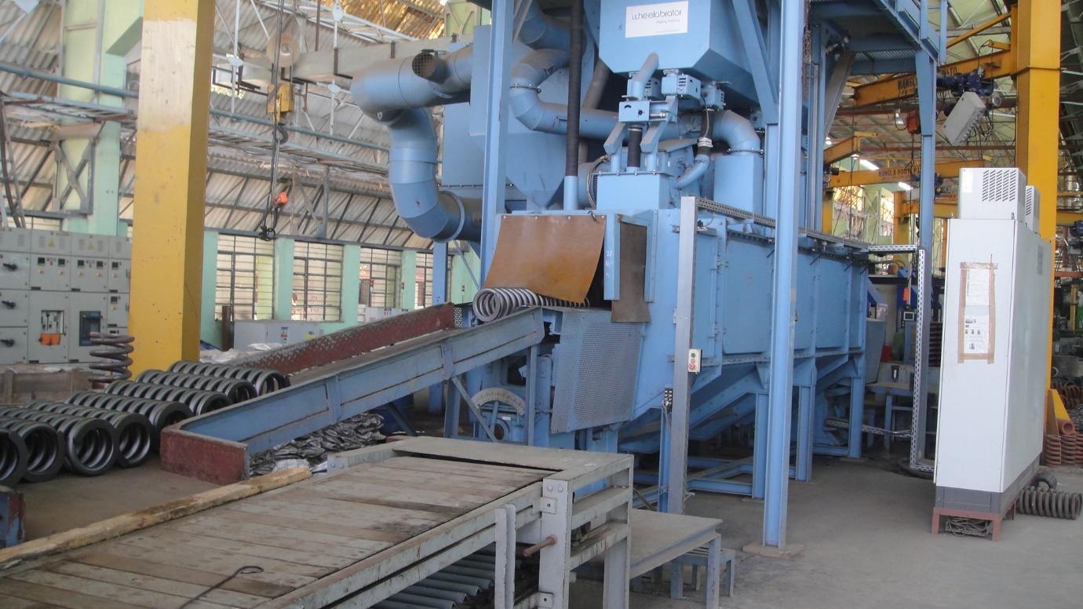
“kkWV ihfuax
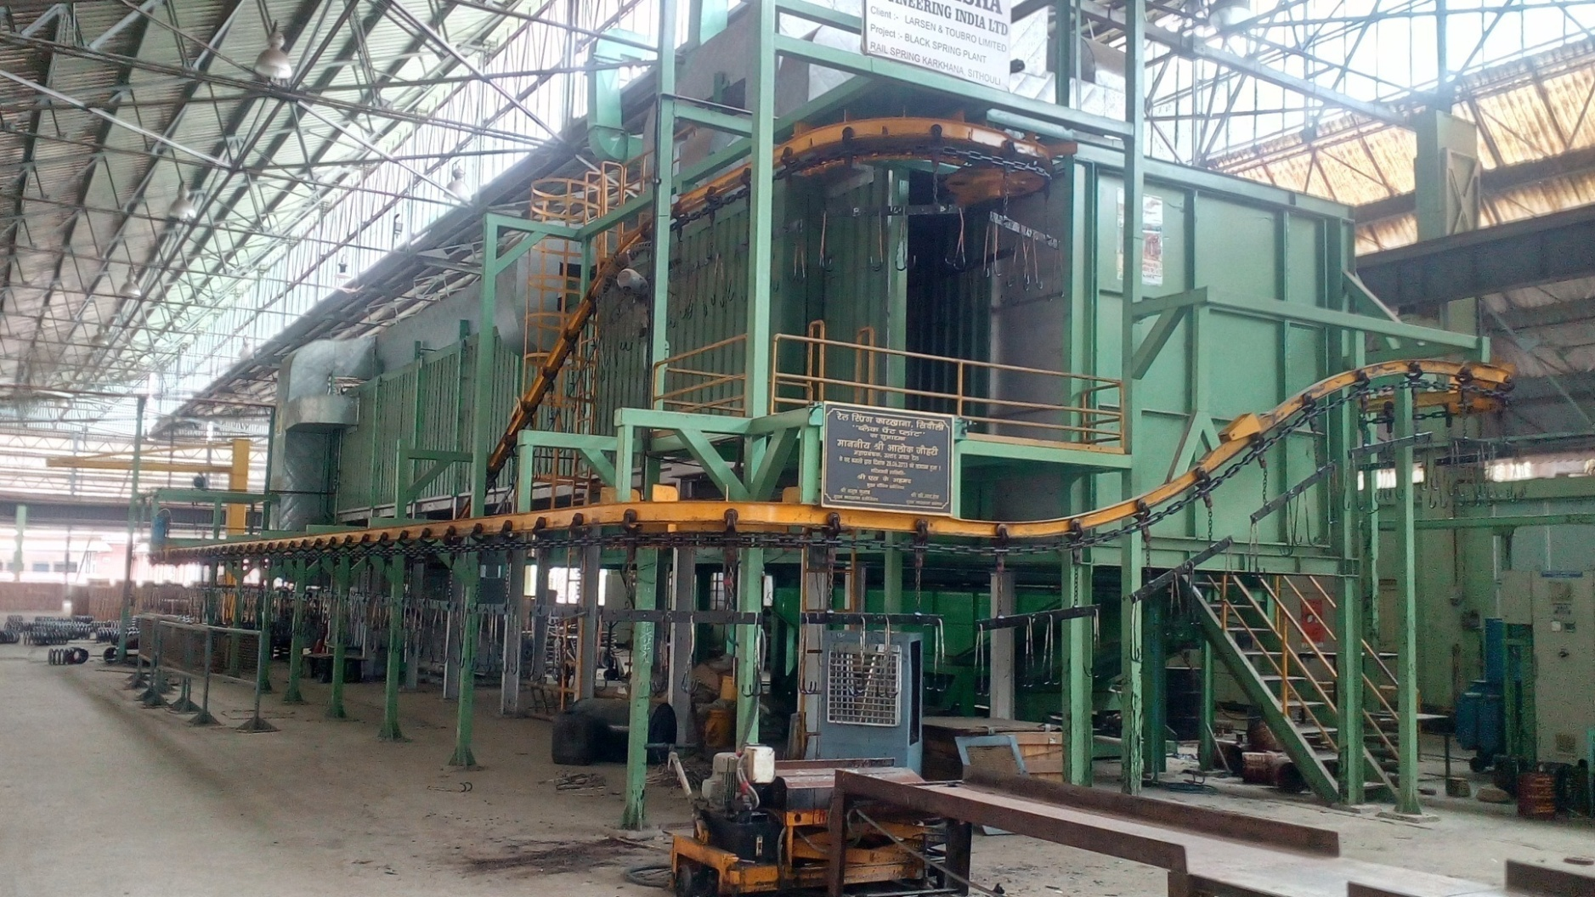
izkbej isaUV IykWV

